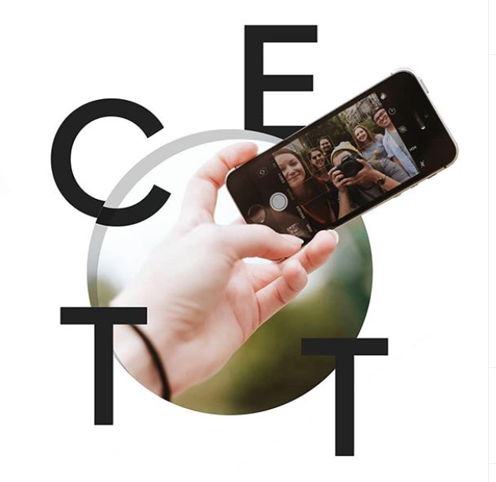
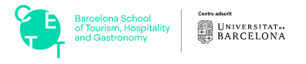

for 2+2 Dual Degree Bachelors in
Hotel & Tourism Management at CETT - University of Barcelona

APPLICATION FORM
Fall Program 2021



APPLICATION FORM Fall Program 2021
for 2+2 Dual Degree Bachelors in
Hotel & Tourism Management at CETT - University of Barcelona

(please type, or print in block letters)

I am applying for: ☐ Fall: September 2021 Student ID:
Current Department at Woosong University: Status:☐ Freshmen ☐ Sophomore ☐ Junior ☐ Senior
☐ Transfer – From which university

Name (Please enter your legal name as it appears on your passport)
NAME in Korean: NAME in English, (Full Name):
Gender: ☐ Male (☐ Finished Military Service ☐ Exempt) ☐ Female
E-mail address:

Mailing address (This address is to be used for official correspondence)

Address:

City: State/Province:

Postal Code: Country:

Phone number: / Mobile Number: /
(Include country code) (Include country code)
Citizenship and other personal data:
Date of birth: (Year/month/day) _ Country of birth:

Country of citizenship: Passport number:

Emergency contact details (The person to contact in case of an emergency)

(PROF., DR., MRS., MR., MS.) Surname / Family name Given Names Relationship:
Phone Number: _/ Mobile Number: _____/ _________________
(Include country code) (Include country code)

E-mail Address:

The following must be attached to your application form:
  - Proof of English Proficiency – either an IELTS score or a TOEFL iBT score. Or TOEIC score. (영어 Certificate는 2021년 5월 28일까지 제출하면 됩니다.)
  - Transcripts stating accumulative Current GPA – Average Grade of Woosong University (English version)
  - Passport
  - Photo

Declaration
I understand that, upon registration, my data may be used for any purpose relating to my study in accordance with the procedures of Woosong University. I declare that the information given in support of this application is accurate and complete, and understand that any misrepresentation will result in disqualification of my application and the termination of the admission process. I give my consent for Woosong University to release as required this information to organizations and persons mentioned herein for the purpose of verifying the data supplied.
I understand that if admitted I am responsible for applying to the immigration department of the Republic of Korea for a student visa to stay in Korea for the entire period of study at Woosong University.
I further understand that I am required to make financial arrangements to ensure all other costs (visa, dormitory, meals, books, personal expenses) required for the duration of my stay in the republic of Korea are covered.

Signature of Applicant Date

Legal Name:
Surname / Family Name Given Names Preferred Nickname
501

